Wireframe document

Thyroid Disease Detection

**Homepage**

We have divided Thyroid Disease Detection’s homepage into two sections: User input section and result section

**User input section**

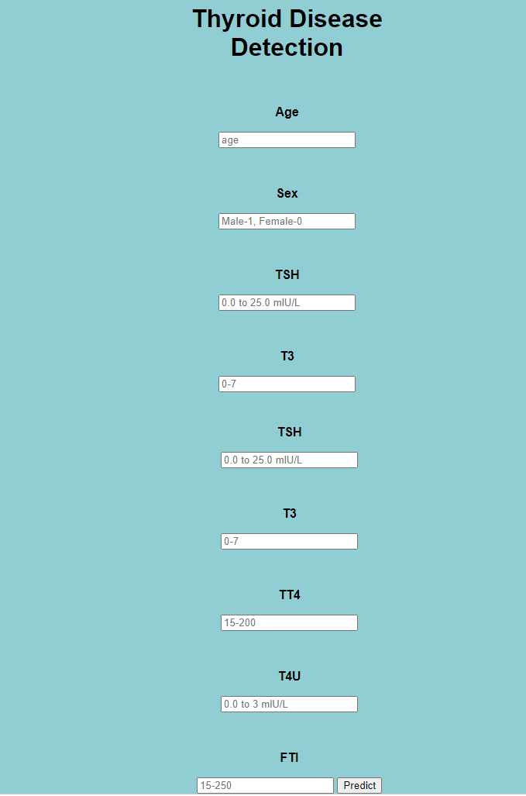

First thing anyone will see on viewing the URL address is the homepage. It will ask the user to enter the all the details of the patient as shown above.

**Result section**

After the user enter the details and hits the predict the output will be shown as given below.

